**Homework 3: Well Transmissions**

**Quantum Mechanics II: PHYS 511**

**Gabriel M Steward**

**January 2022**

**Texts Referenced:**

**Modern Quantum Mechanics, Sakurai and Napolitano**

**Introduction to Quantum Mechanics, Griffiths and Schroeter**

**(Further references at the end)**

**Problem 1**

*Define the function G(λ)= and prove that*

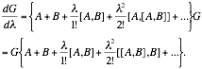

*Use this to show that if A and B are operators that both commute with their commutator [A,B],*



We are given the function G(λ) and seek to find its derivative. Let’s just take it directly with the product rule:



The enclosed B-operator is in a known form that can be expanded. This gives us:



Which is the first part of what we needed to show. Now, though, we need to show G on the left side—specifically, that it would flip the commutators. Let us try doing it directly…

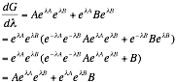

This is a curious result. Not what we were going for, but apparently B and its own exponential commute. We can make use of this with A.

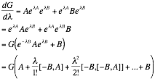

Having a minus sign is the same as flipping the commutator.



Which is exactly what the first part of the question has asked us to show.

Now we somehow have to use this to show the following:

**

With the knowledge that A and B commute with [A,B].

Looking at our full relation:

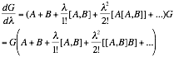

If A and B commute with their commutator, then all the higher terms vanish to zero because they’re being put in a commutator *with* their commutator.



This also means that, when A and B commute with [A,B], they also commute with G since G has to be able to move all the way across without changing anything it moves across! This is consistent with what we know of operators being able to commute with their own exponential forms.

Anyway, let’s attempt to turn this into a differential equation and solve for G directly.

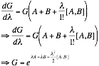

The trick was remembering that we were treating lambda as a variable. For our case, lambda just equals one, and we get:

|  |
| --- |
|  |

Which is exactly what we sought to prove.

**Problem 2**

*Obtain the transmission probability for a rectangular barrier of width 2a when the energy E exceeds the height V0 of the barrier. Plot the probability as a function of E/V0 up to E/V0=3, with .*



Splitting up the potential into two sections: Section I on the left, Section II in the middle, and Section III on the right, with the boundaries at x=±a. Section I has the standard solution for a free particle.



Where k=√(2mE/ћ2). Section III has much the same.



However, G=0 as we will not have an *incoming* wave on the other side of the barrier.

Section II is similar, but the value for k is replaced with k’.



Where k’=√(2m(E-V0)/ћ2). E is above the barrier, so we used this version.

First, let us get C and D in terms of F using the continuity requirements at a and -a.



Different linear combinations of the two produce the following:

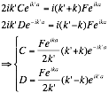

We then compare these with the continuity equations between AB and CD.



In both of which, substitutions can be made. Since there’s a bit of algebra here we’ll only consider one at a time.

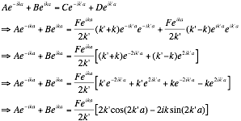

Since we mainly want ratios, it seems likely the other one will have similar terms. So we seek them when we solve it.

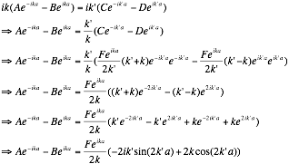

Through linear combination of the equations, we can get equations for A and B.



We technically have A and B now. Simplifying:

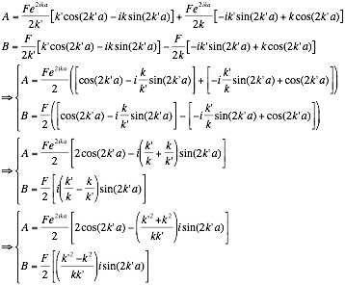

Which, while not exactly the simplest, is still workable. It seems as though it will be easier to find R than T in the form we currently have. Both k and k’ are real in this case, as E>V0.

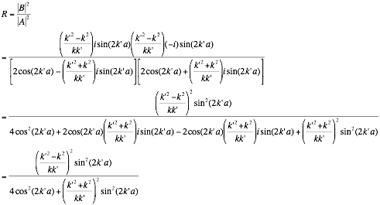

Which, while long, is technically correct. It may be simplifiable but it is actually workable in this form. Considering how much time we’ve spent already, we really should just take this and only come back if we have significant time. The second-to-last step is the most compact version, so we will use that for our plot.

Now that we’re going to be plotting, we need to examine the values of k and k’.

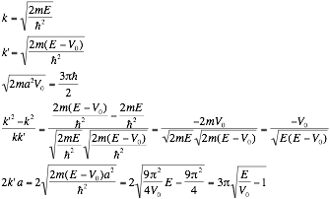



And with all of this (often somewhat rather arbitrary) work we can simplify our reflection probability. (And then get T from that).

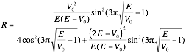

Now we seek to get everything in terms of E/V since that’s how the problem words itself. We’re almost there, we just need to manipulate certain parts that aren’t obvious just yet…

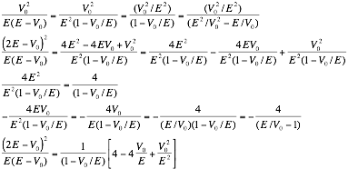

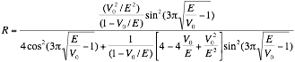

While this is ugly it serves our needs. IF we let E/V = x, we now have



And T = 1-R. We will not be explicitly writing this out. There is no doubt a way to cancel the 4cos2 term but we don’t have to find that.

Geogebra can easily graph both T and R from this:

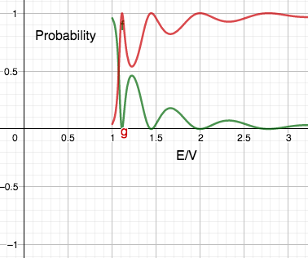

Red is transmission probability, green is reflection. They behave as expected, though are notably not classical at all: the probabilities oscillate and fluctuate near the limit before leveling off. A curious quantum effect.

**Problem 3**

*Construct the transcendental equations for the bound-state energies of the double-delta-function well (g>0)*



*Plot the energy levels in units of* ћ2/ma2 *as a function of the dimensionless parameter mag/*ћ2. *In the limit of a large separation, obtain a simple formula for the splitting ∆E between the even and odd parity energies.*

As usual with situations like this, we split it up into three sections. As these are just dirac deltas, and our energy is *less* than zero since we have bound states. Thus, our wavefunctions are…



Since the bounds for I and III go to infinity, the solutions can’t blow up there since we are in bound states. Furthermore, as the potential is symmetric, the overall solution for the probability of bound states must also be symmetric. This means the magnitude of D must equal C, and A must equal G. However, they can be positive or negative, that is, even or odd.



In this case κ=. We have wavefunction continuity, but *not* derivative continuity. Instead, we have the dirac delta discontinuity:



Although in our case α=-g, so this will end up being positive.

Our equations we obtain are now:



For even solutions and



For odd.

Note that we are not solving for A and C this time (they would be done through normalization if we cared), we want κ so we can find the allowed E values.

Let us handle the even case first. Most of this work we did previously in Undergrad.

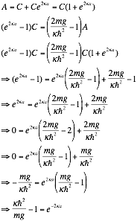

Which is a transcendental equation.

The steps are functionally identical for the odd solutions, so they won’t be repeated. The result is



If we do some substitutions, say, z=2κa and c=ћ2/2mga we can force these transcendental equations into a much easier form

Even: e-z=cz-1

Odd: e-z=1-cz

Which is how we originally solved it in undergrad. It also appears to be correct for this problem as well, as E=-κ2ћ2/2m which, if we let κ=z/2a, this becomes



For both even and odd, where allowed values of z are determined by the transcendental equation. It’s in the right units!

However, currently this is a function of parameter “z” not parameter “mag/ћ2”. Which is “2/c” in our model. If we adjust our transcendental functions with d=mag/ћ2, we get:

Even: e-z=2z/d-1

Odd: e-z=1-2z/d

Now, once given a d, we can solve for all z solutions, which give the different energy levels. But as these are transcendental equations *the relationship cannot be made direct* as we *cannot solve directly for z.* But we can set c to a slider on a graph to demonstrate how this will work in GeoGebra.

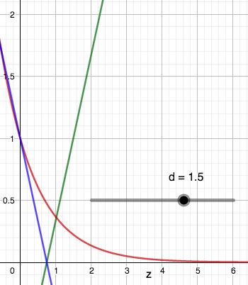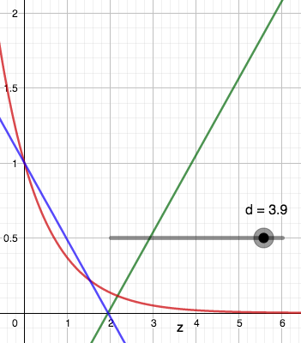

These are just the direct transcendental equations: e-z is red as it appears in both solutions. Even is green, odd is blue. Note that there are no odd solutions for low “d”, but there is always one even solution. To make this show energies, we need to use the E=–z2/8 relation in the specified units. That produces, using the same color scheme as above:

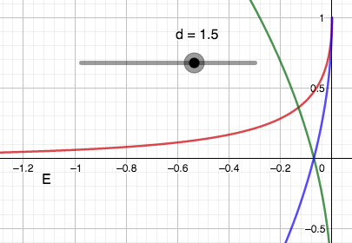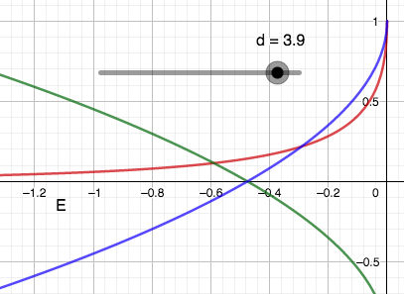

To reiterate, allowed energies only occur where the green and blue functions cross the red one. As seen before, no odd solution exists for small d.

In the limit of large separation—that is, large a—d and z also become very large. The convenient part of this is that e-z gets closer and closer to zero the further out one goes. This means the transcendental equations are roughly equivalent to:

Even: 0=2z/d-1

Odd: 0=1-2z/d

For these to be true, z must equal d/2 for both even and odd cases. *This means that as a increases towards infinity, the ∆z and thereby the ∆E approaches* ***zero***. The two bound states become impossible to tell apart!We can see this in Geogebra as well.

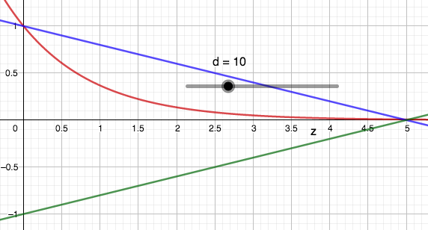

With d=10 the two functions might as well be crossing at the same point. They aren’t quite—as e-z doesn’t actually touch the axis. However, in the a->∞ limit, it does.

Followup: If we didn’t want it quite at infinity, but still in the large a limit, there is another formula we can develop. Take e-d/2. Anywhere near e-d/2 is essentially a flat line, so we can use basic slope calculations to find ∆z.

Even: e-d/2=2z/d-1 => z = (d/2)(e-d/2+1)

Odd: e-d/2=1-2z/d => z = -(d/2)(e-d/2-1)

The ∆z is just the difference between the two.

∆z = de-d/2.

And so ∆E for this case would be



But this would just be for relatively large a, not the large a limit.

**Additional References:**

GeoGebra Classic (Graphic Program, also used for some calculations).

No others ended up being needed today!